This hotel was torn down many many years ago. It was across the railway from the current Amtrak Station. The land is vacant. Lamy is the stop for Santa Fe, New Mexico. The Santa Fe Southern operates trains between Lamy and downtown Santa Fe. La Fonda, the Harvey Hotel at the end of the Santa Fe trail is across town from the Santa Fe depot.
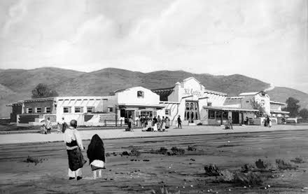
El Ortiz Hotel and Lunchroom at Lamy, NM. Photos courtesy Fred Harvey Collection, Cline Library, Northern Arizona University, Flagstaff, AZ

